L298N Dual H Bridge Truth Table
ENA / ENB | IN1 / IN3 | IN2 / IN4 | Motor State
0 | - | - | Off
1 | 0 | 0 | Fast Stop
1 | 0 | 1 | Reverse
1 | 1 | 0 | Forwards
1 | 1 | 1 | Fast Stop

Chassis Information
Chassis number | 1 | 2 | 3 | 4 | 5 | 6 | 7
Chassis name
Drive wheel teeth | 20 | 20 | 20 | 20 | 20 | 20 | 20
20 teeth worth of drive track | 16.2cm | 16.2cm | 16.2cm | 16.2cm | 16.2cm | 16.2cm | 16.2cm
Left Motor no load RPM forward
Left Motor no load RPM reverse
Left Motor pulses for 10 revolutions
Right Motor no load RPM forward
Right Motor no load RPM reverse
Right Motor pulses for 10 revolutions

Pins
D0 | Serial Rx | -
D1 | Serial Tx | -
D2 (Interrupt pin) | Right hall effects | Input (requires internal pull ups to be enabled)
D3 (Interrupt pin) | Left hall effects | Input (requires internal pull ups to be enabled)
D4 | Ultrasonic Forward Trigger | -
D5 | Ultrasonic Forward Echo | -
D6 (PWM) | Servo | Analogue Output
D7 | IN4 | Output
D8 | IN3 | Output
D9 | ENB | Output
D10 | ENA | Output
D11 | IN2 | Output
D12 | IN1 | Output
D13 | Ultrasonic Down Trigger | -
A0 / D14 | Left LED | Output
A1 / D15 | Right LED | Output
A2 / D16 | Right LDR | Analogue Input
A3 / D17 | Ultrasonic Down Echo | -
A4 / D18 | I2C SDA | -
A5 / D19 | I2C SCL | -
A6 | Middle LDR | Analogue Input
A7 | Left LDR | Analogue Input

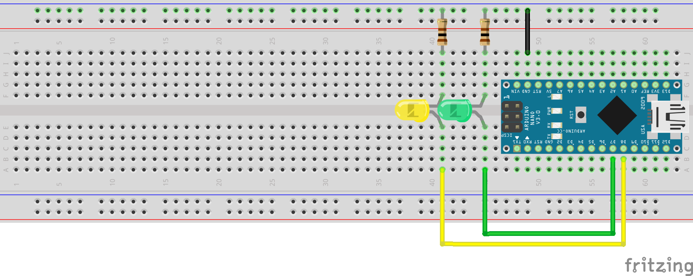
Story 2

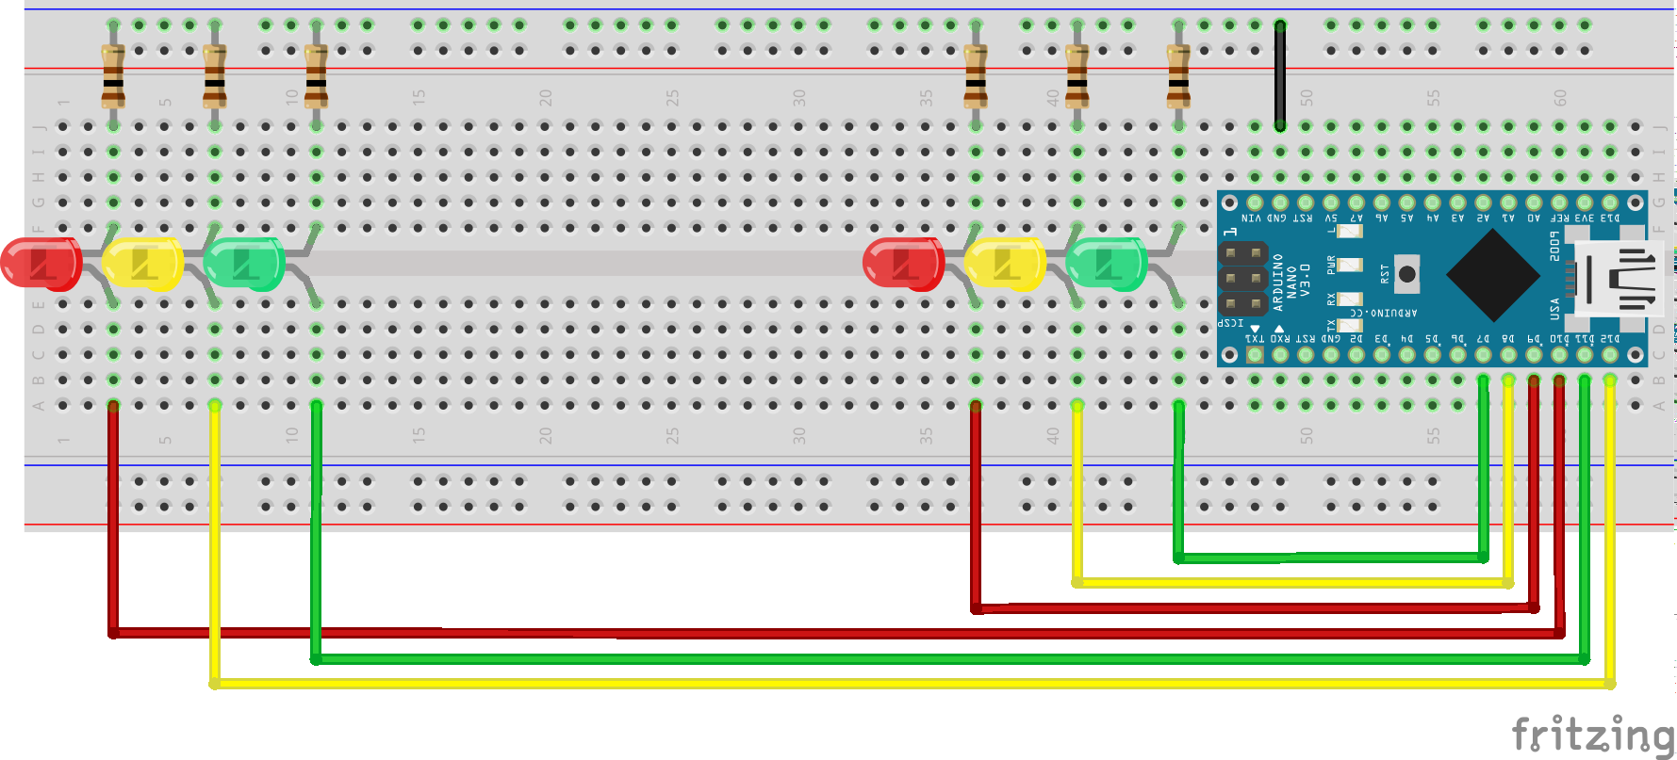
Story 3

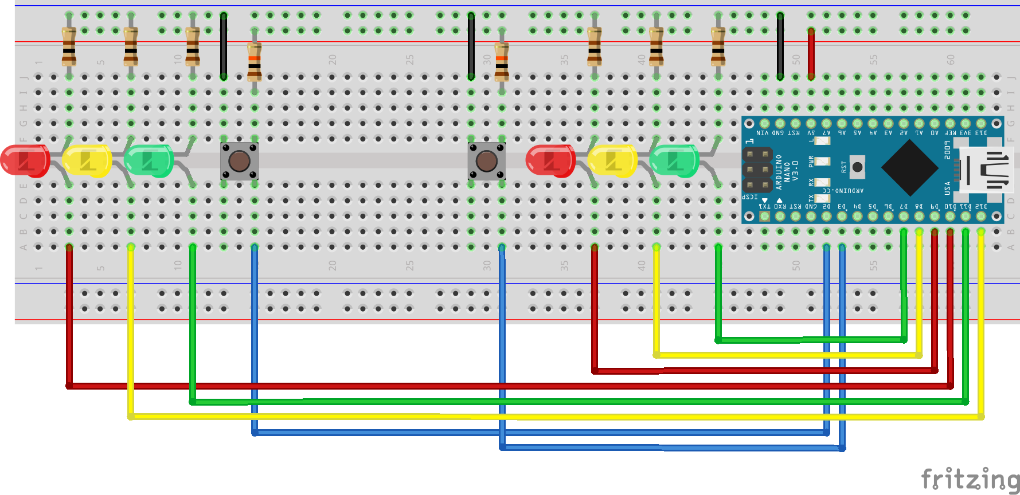
Story 5

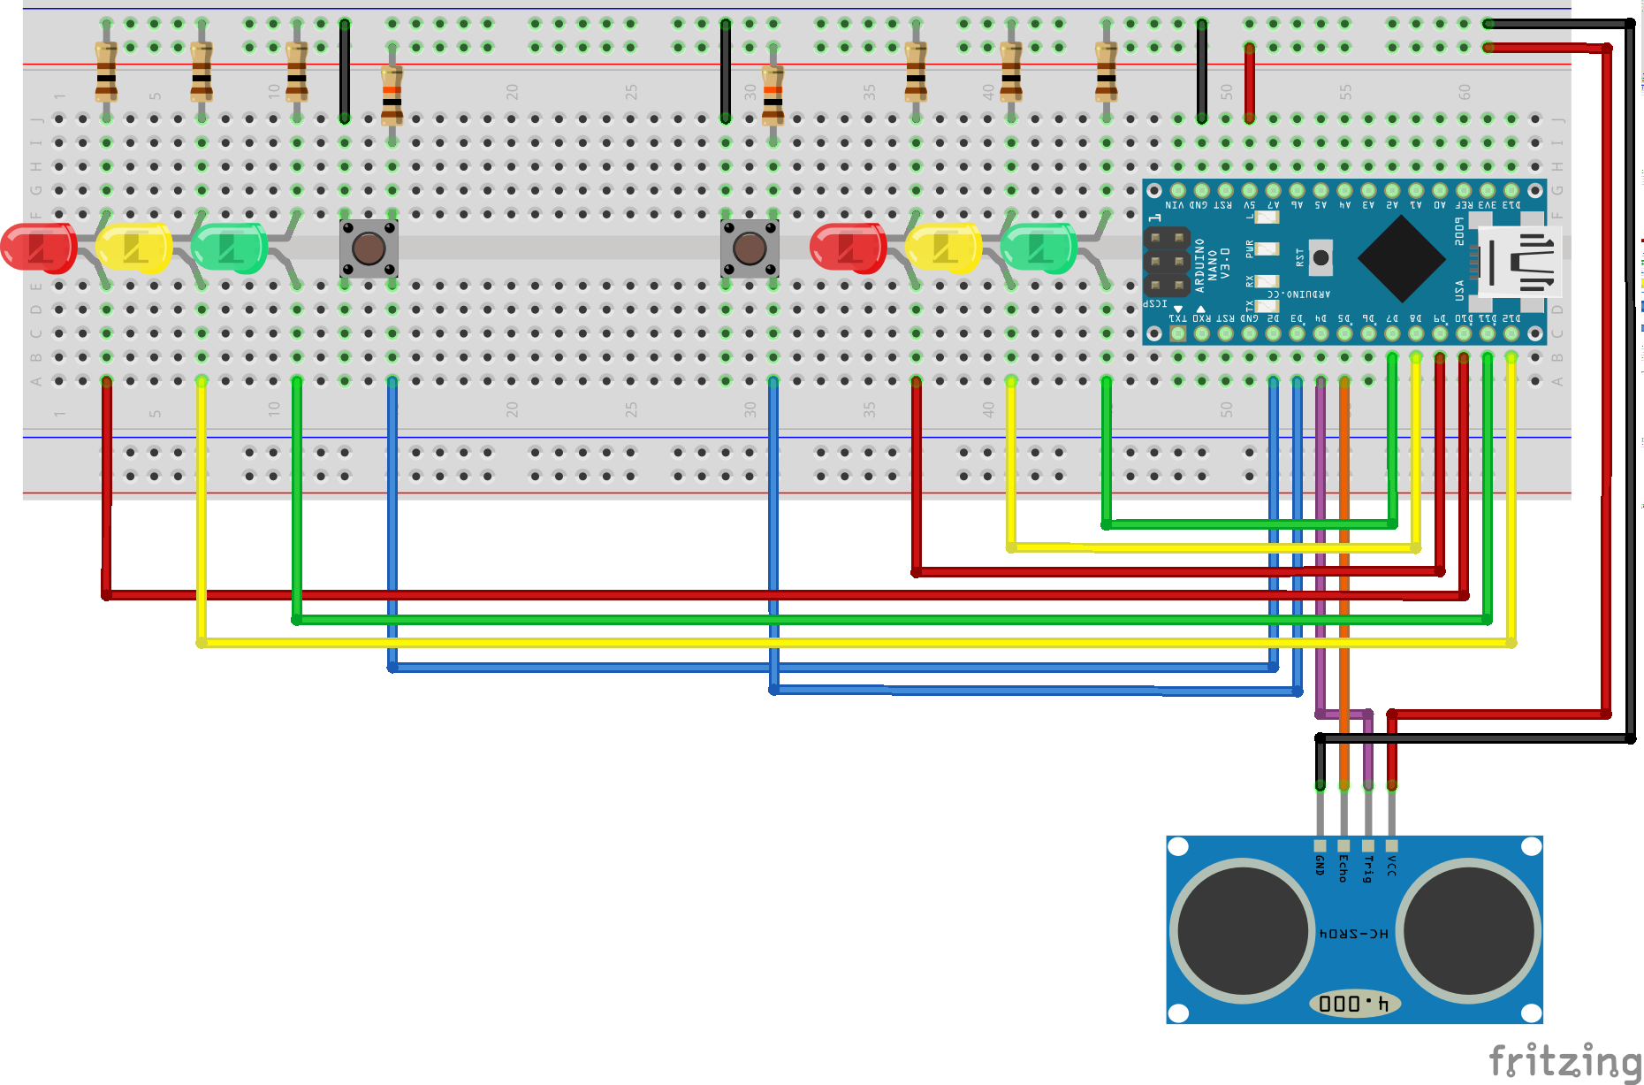
Story 9

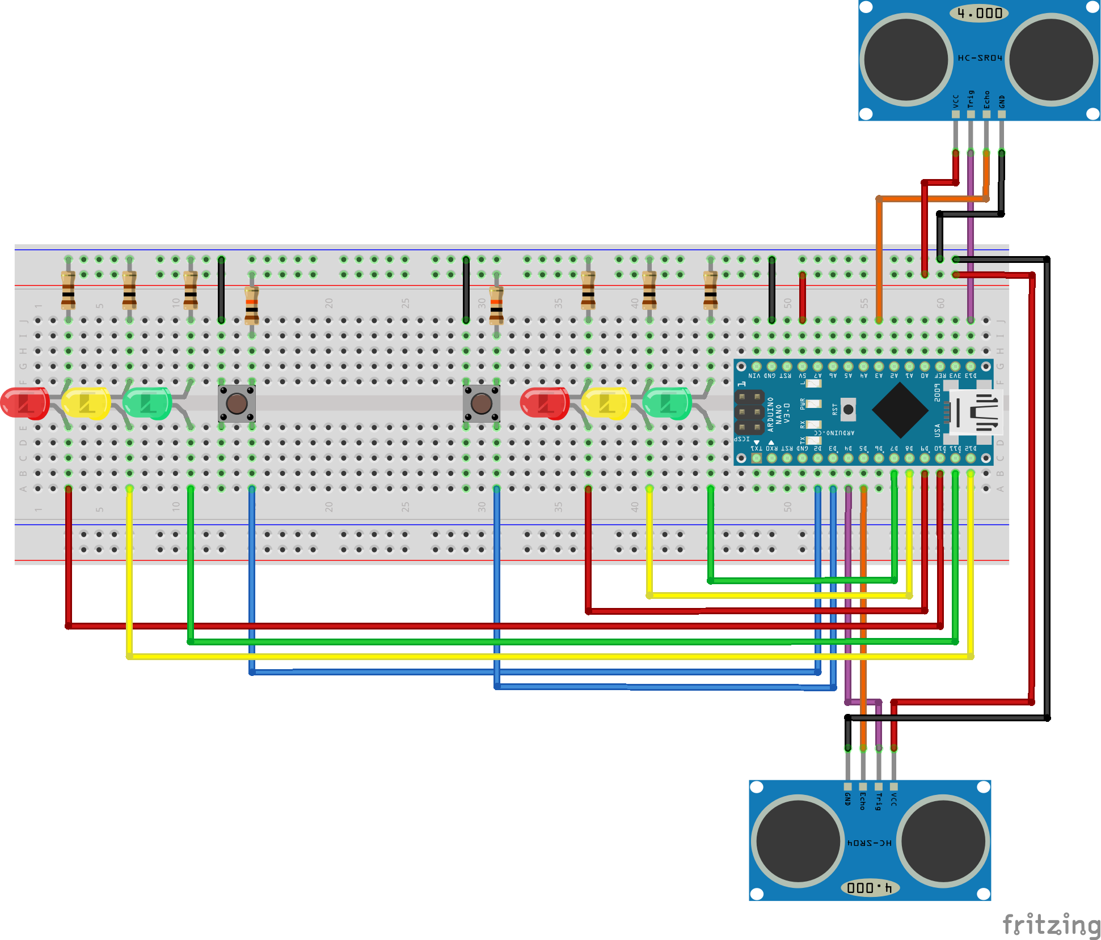
Story 10

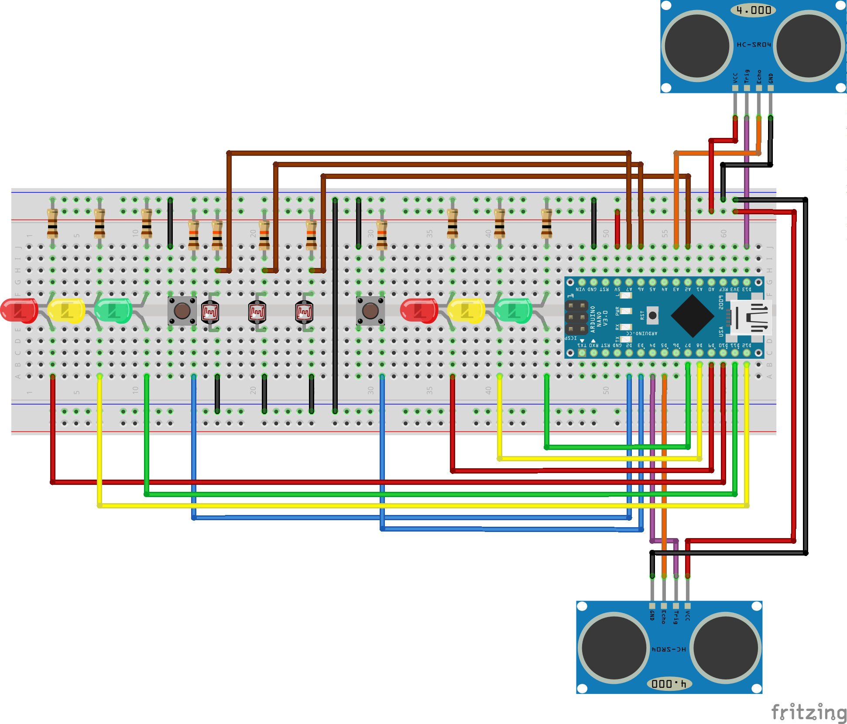
Story 11

